

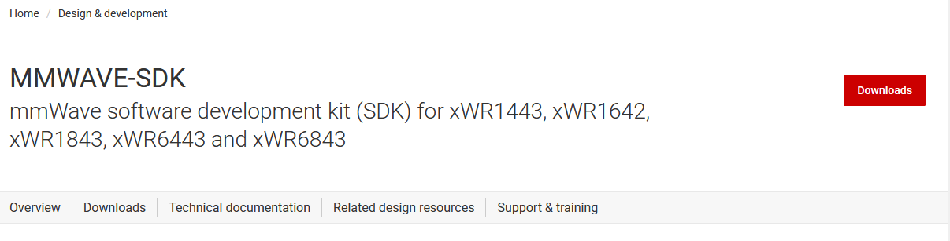
Click download

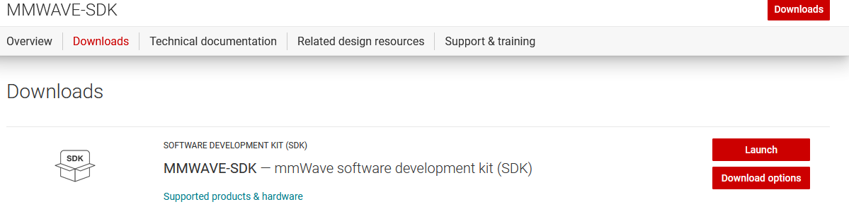
Click download option

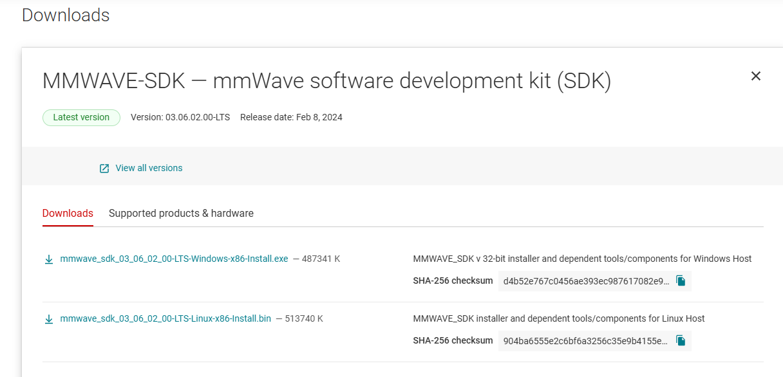
Click window host for installation of SDK

CCS


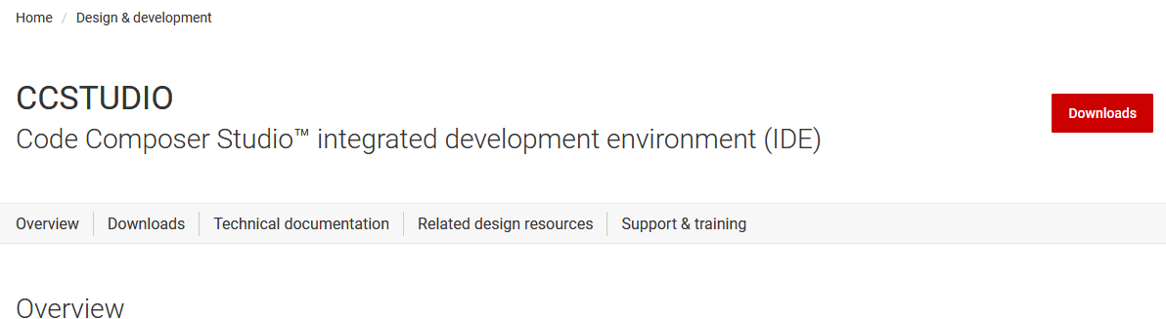
Click on download
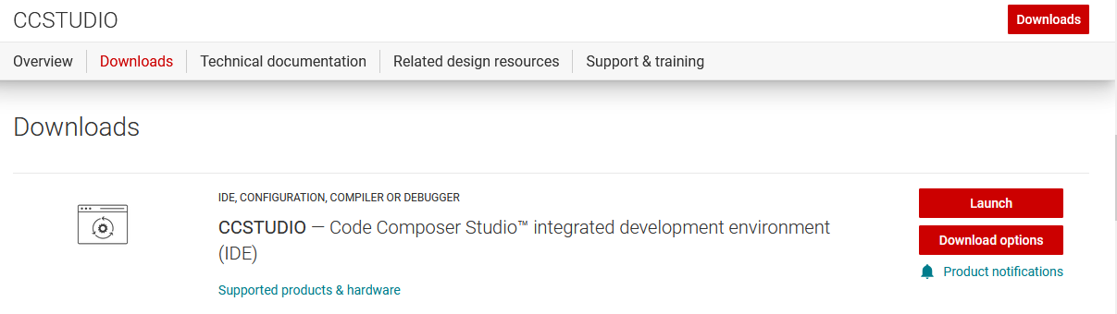
Click on download option

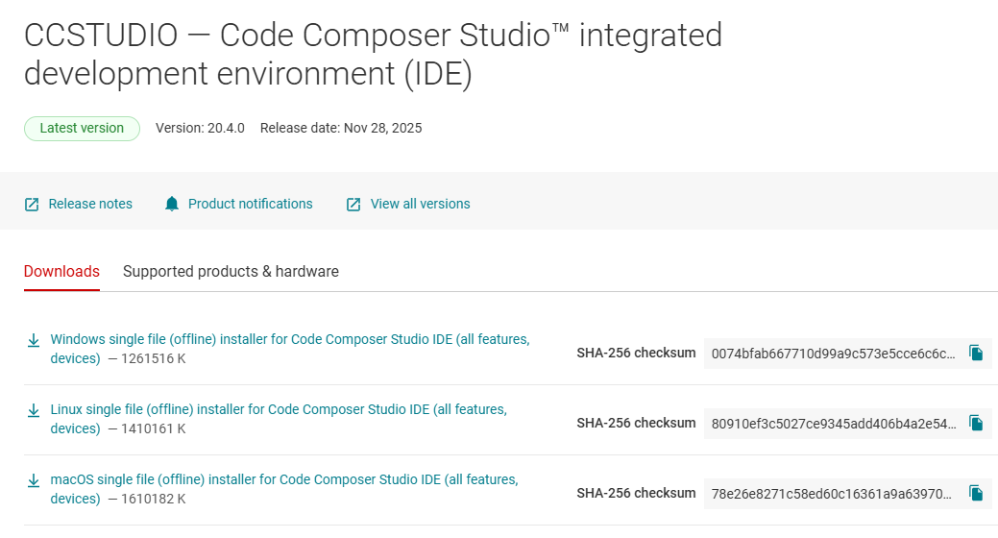
Click on windows single file

- Open CCS
- Resource explore option
- Mmwave radar sensor
- Embedded software
- Radra toolbox 3.30.00.06 install( u can see on the top header it is visible)

- 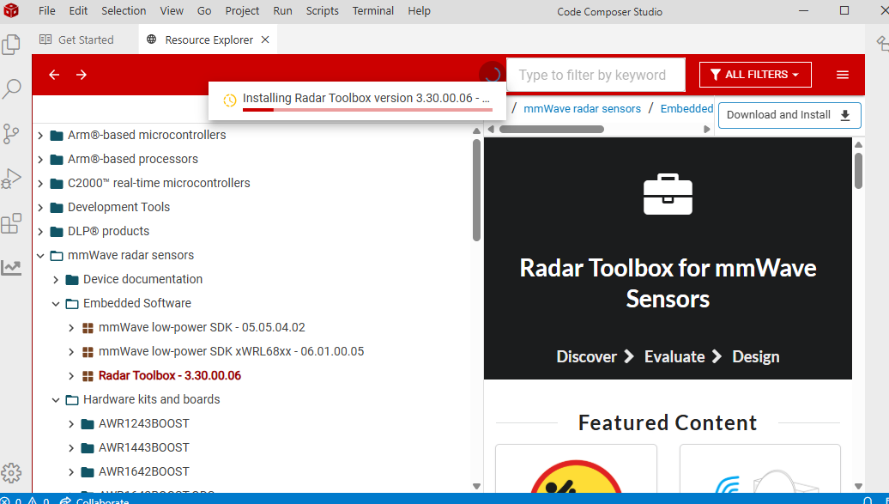

Install Uniflash


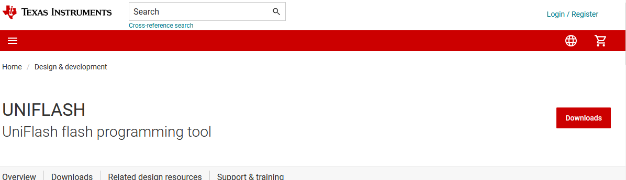

Click on download
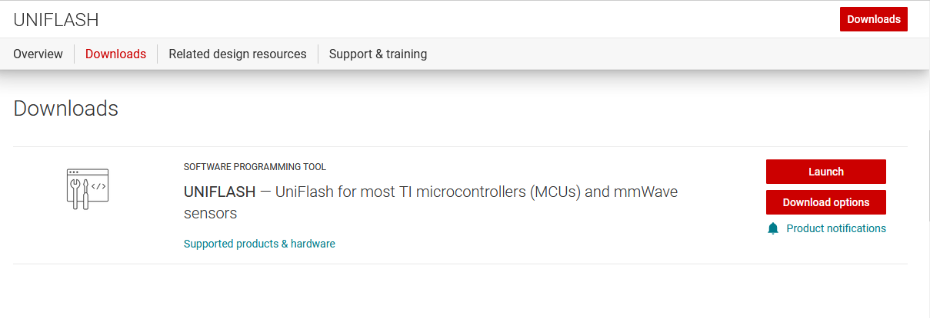
Click on download option

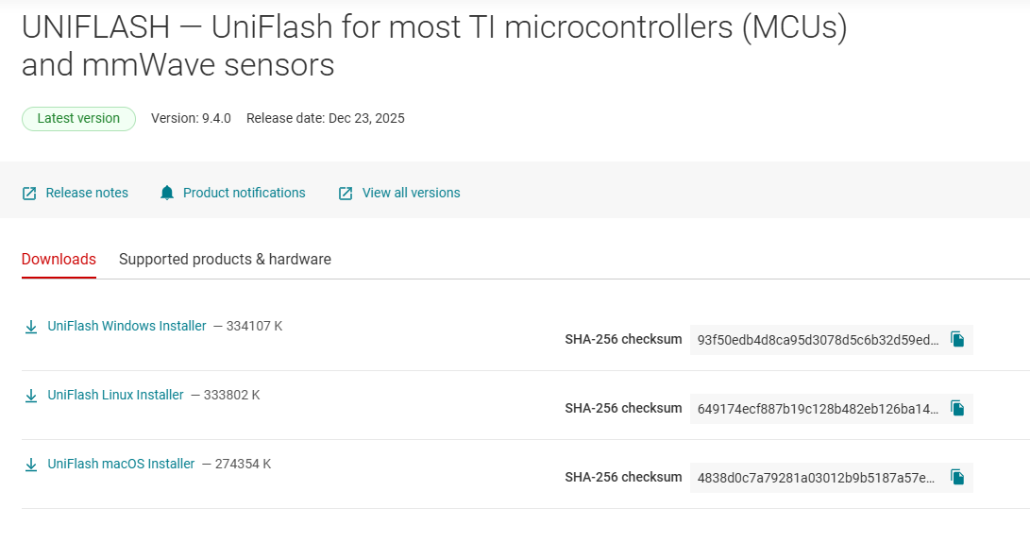
Click on uniflash windows installer

Open and run the exe file

(Search Uniflash)

- Select the device ,

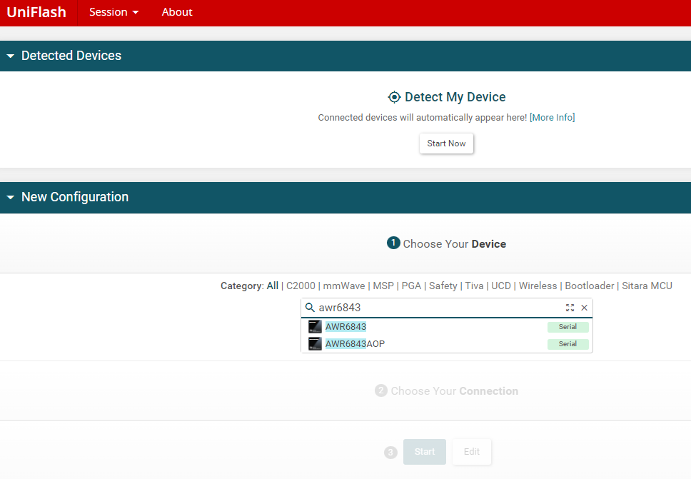

- Settings and utilities

In the opened device window click on settings and utilities(to find the com port from device manager: check for enhanced port used for flash) the port is used for data
In case Port may not be visible in device manager then (need to install other software cp210X driver)
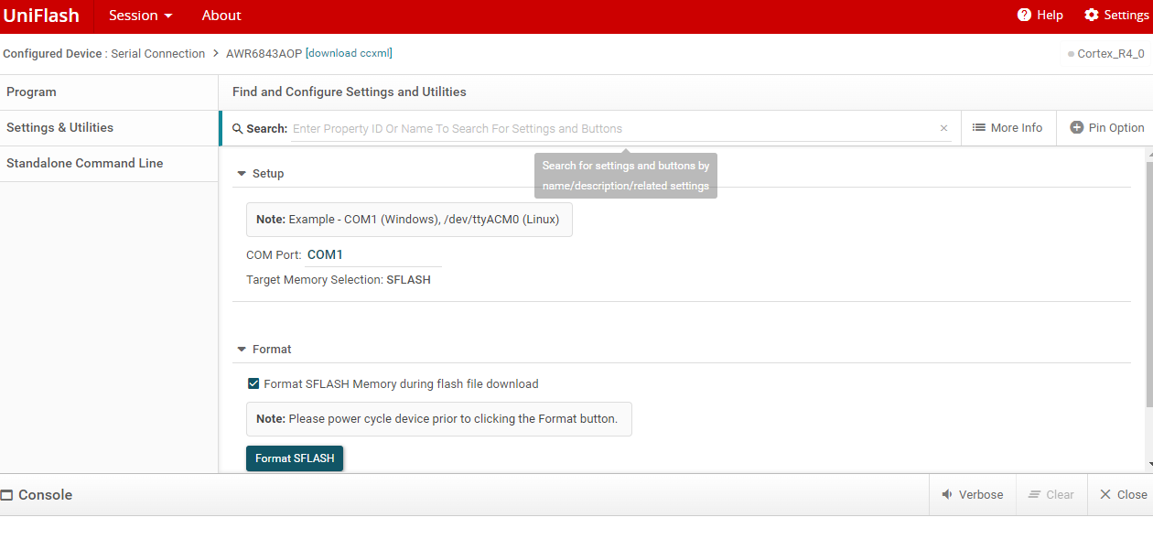

_install the cp210x driver (to check the com port in device manager )

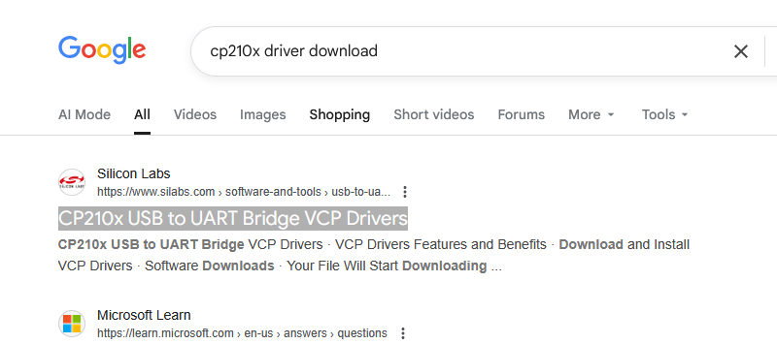
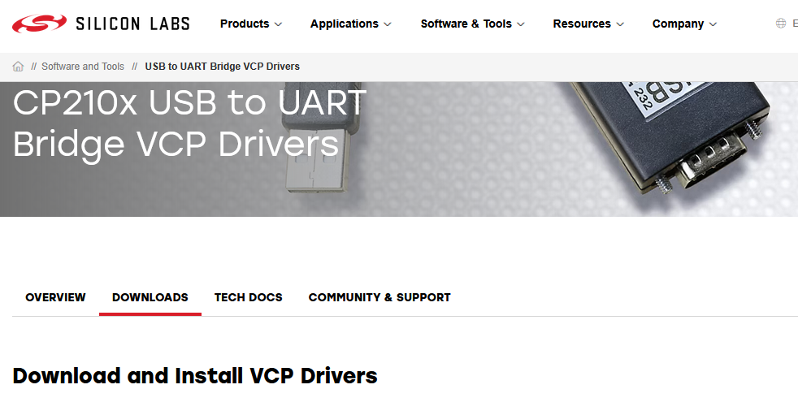
Click on download
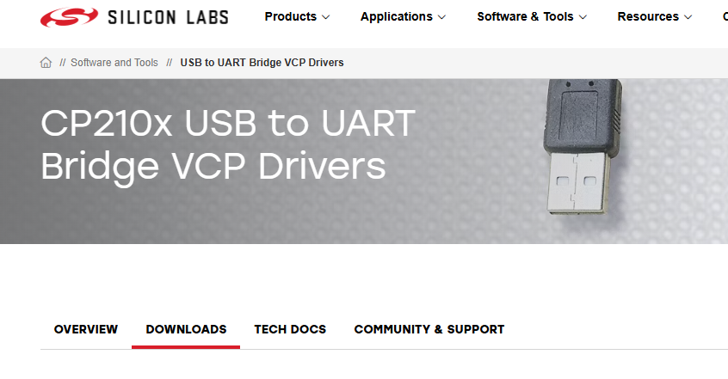
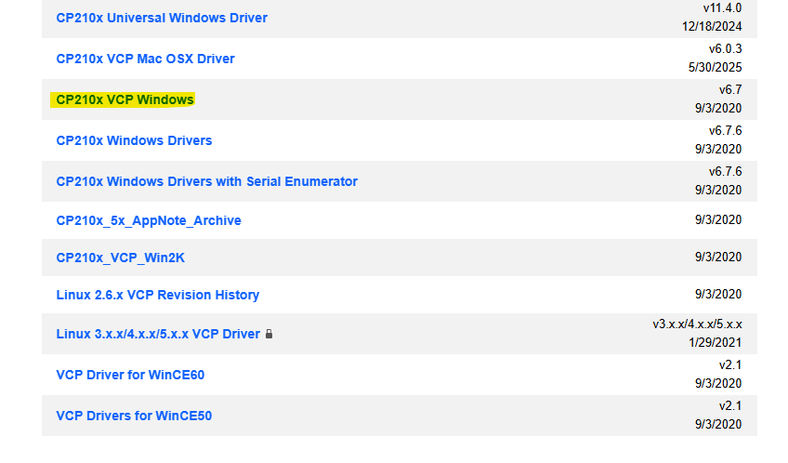
Extract the exe file (available in downloads)

Check in device manager for com port number(Enhanced for flash , standard for data)

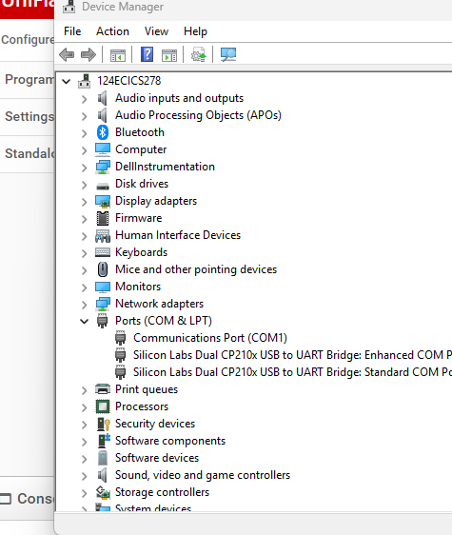

- program
(in uniflash (click on Program )to select the bin file to be flashed) path of bin file , load image (pin to be selected on flash mode , first pin from holder)
C:\ti\radar_toolbox_3_30_00_06\source\ti\examples\Industrial_and_Personal_Electronics\People_Tracking\3D_People_Tracking\prebuilt_binaries

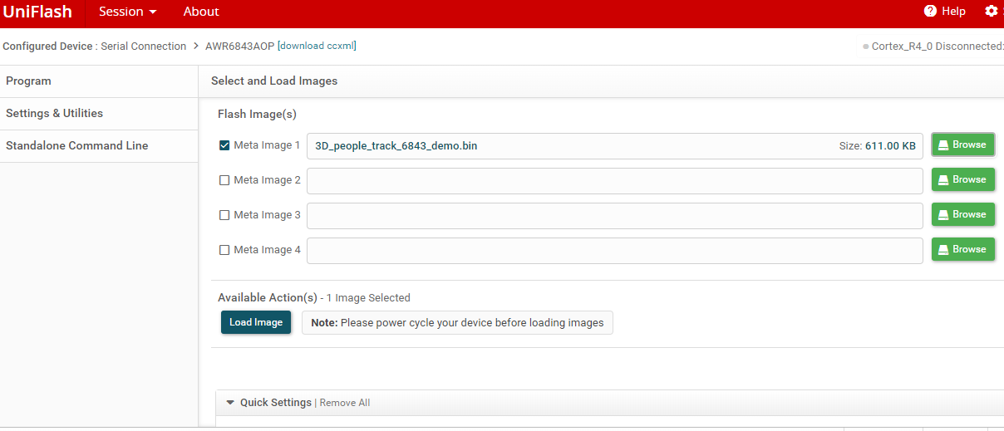
Open the visualizer
:
C:\ti\radar_toolbox_3_30_00_06\tools\visualizers\Applications_Visualizer\Industrial_Visualizer
(to open Visualizer window) (precautions , pin setting to be on data type , unplug the radar and plug in again)
- Select device
- Com and data port to be entered
- Demo from pop up window
- Connect
- Select configuration file
- Click on start and send configuration

(To select configuration file in visualizer)

C:\ti\radar_toolbox_3_30_00_06\source\ti\examples\Industrial_and_Personal_Electronics\People_Tracking\3D_People_Tracking\chirp_configs

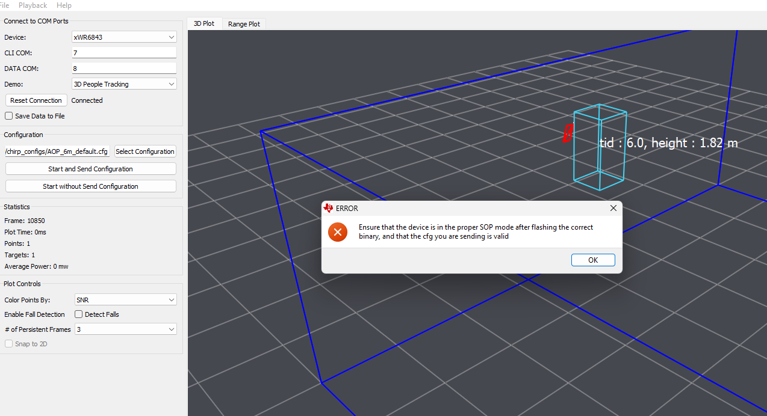
(to avoid above error , restart the visualizer and unplug the radar and reconnect)

To record the data as JSON file 👍(path where data will store)

C:\ti\radar_toolbox_3_30_00_06\tools\visualizers\Applications_Visualizer\Industrial_Visualizer\binData
(path for the recorded data in JSON)

Short steps after installation of

To open uniflash(search the device , select the devic e, start now)


Select RADAR device
- Settings and utilities _Select comport (device manager)
- Program (select bin file , click on load image)

Start with Visualizer (using path)

